Historical Figures Report

Thato Radebe

St10441385

<https://github.com/thatoxradebe/HistoricalFigures>

Introduction

For my first IMAD Assignment, I have created an application for young students that I have named Historical Figures.

The purpose of this app is to give interested students a bit more insight into the lives of some historical / well-known individuals who have had an impact in society in one way or another. I made the application in Android Studio with kotlin being the language.

How to use Historical Figures

Upon opening the application, the user immediately sees the main page which consists of 2 buttons and 2 text fields. In order to use the application, the user would have to input a number preferably between 20-100 to generate an age. I have made the app using a total of 16 historical figures that students could look into. If the age that has been input correlates to the age of a historical figure that has been generated by the app, the resulting output will be the name of the historical figure, some information regarding them and that age in question is the age that the person was when they passed away.

If the age that has been input does not correlate with any historical figure that has been recorded in the application, the resulting output will read, “There is no famous figure who passed away at that age, please try again.”

If the user were to type in a number that is out of the age range of 20-100 and therefore does not correlate with any historical figure that has been recorded in the application, the resulting output will then read, “Invalid input, please enter an age between 20-100.”

The user of the application will be able to type in the age of their choice, between 20-100 in the edit text field which reads “Enter Your Age”. With the use of the “Generate” button, the resulting information will be displayed below in the text view. Next to the “Generate” button there is also a “Clear” button as well. The purpose of this button is so that the user can refresh/reset the app so that they are able to type in a new input and display a different output.

Historical Figures Used in the App

Below are two examples of the historical figures that will be found in the app:

Fidel Castro (August 13 1926 – November 25 2016). Fidel Castro was a Cuban politician and freedom fighter who was also the leader of the Communist Party of Cuba. Fidel Castro was seen as a hero to many for his anti-imperialism beliefs as well as for being instrumental in securing Cuba’s independence from America. (Britannica, 2024.)

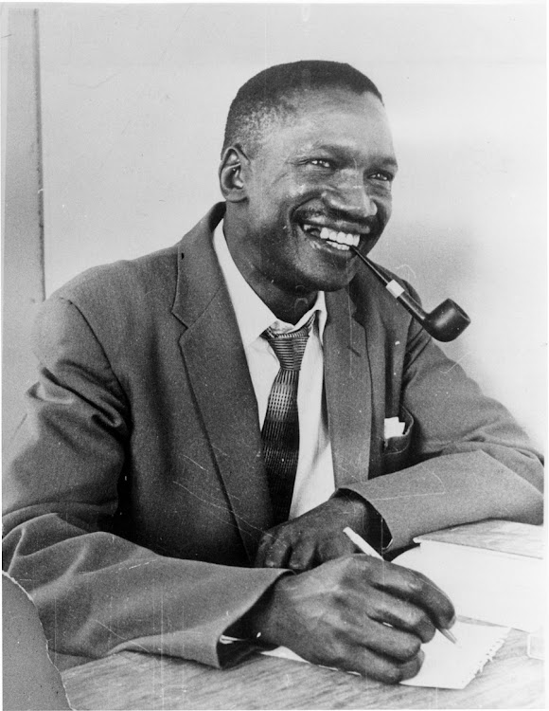

Robert Sobukwe (5 December 2924 -February 27 1978). Robert Sobukwe was a freedom fighter and political party leader of the Pan-Africanist Congress. He was very well loved and respected by his fellow South Africans that shared his Pan-Africanist beliefs. He was also an active member of the African National Congress during the 1940’s and is surely one of the most important figures in South Africa’s history in the fight against white oppression. (SouthAfricanHistoryOnline, 2023)

CODE BREAKDOWN

Creating this application was very enjoyable and simple as there is not too much that had to go into it.

The application’s most fundamental features are it’s 4 variables.

These variables include:

Button

Button

PlainText

Text View.

I first declared all 4 of these variables using “private lateinit var”.

Thereafter, the give these variables functions, I initialized them using “findViewById”. Both of these methods I learned in my lectures.

To make my buttons clickable, I used “setOnClickListener” followed by what specifically I wanted the buttons to do. With my “Generate” button, I wanted for users to be able to click it and see if they were able to generate a historical figure on the app. However, if there was no historical figure on the app with the number that was input by the user, I had to account for that as well, with the basic use of if/else statements.

val age = etEditText.text.toString().toIntOrNull()

if (age != null && age in 20..100) {

val famous = when (age) {

27 -> "Amy Winehouse, an English singer and songwriter"

val message = if ( famous ! =null) "The historical figure who passed away is $famous"

else "There is no famous figure who passed away at that age, try again"

etTextView.text = message

In the case of a user typing in an age that is out of range, they will see a specific output for that as well, as per this code:

}else {

etTextView.text = "Invalid input, please enter a valid number between 20-100"

After the user attempts to generate a historic figure or any other output appears, they will then be able to refresh/restart the app by clicking the “Clear” button as per this code:

}etClearButton.setOnClickListener {

etEditText.text.clear()

etTextView.text = ""}

Reflection

I enjoyed making this application and I am of the opinion that it was very suitable for our first IMAD Assignment. I found it very straightforward to make because of the fact that all the applications functions were already concepts that we had been taught in lectures prior. If anything, it was merely a matter of remembering what we had worked on before, utilizing that knowledge and information and changing it for the specific requirements for this application. I am eagerly looking forward to the work that awaits us in the future.

Reference List

Robert Sobukwe, 05 December 2023 [Online].

Available at <https://www.sahistory.org.za/people/robert-sobukwe>

Fidel Castro, April 2024 [Online].

Available at <https://www.britannica.com/biography/Roberto-Valero>